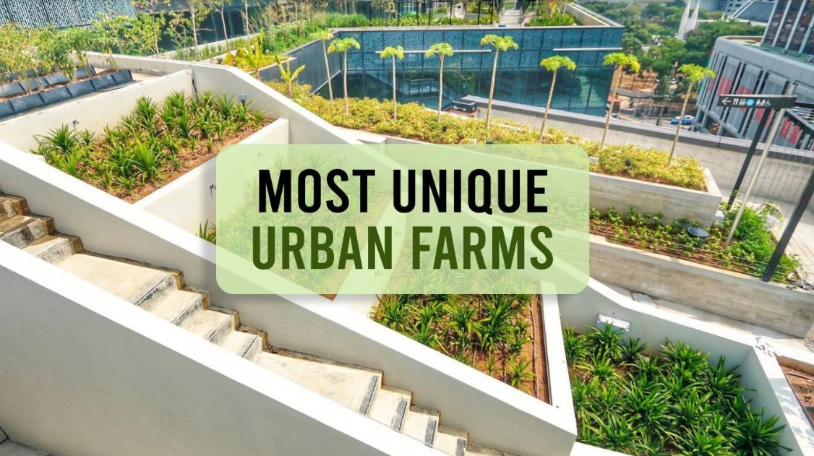

  

Quality Products Reasonable Price Organic Framing

About Urban Agriculture:

Urban agriculture refers to the practice of growing, processing, and distributing food, as well as cultivating plants and raising animals, within or around urban areas. It can take various forms, including community gardens, rooftop farming, vertical gardening, and aquaponics. Urban agriculture contributes to food security, sustainability, and community engagement in cities.

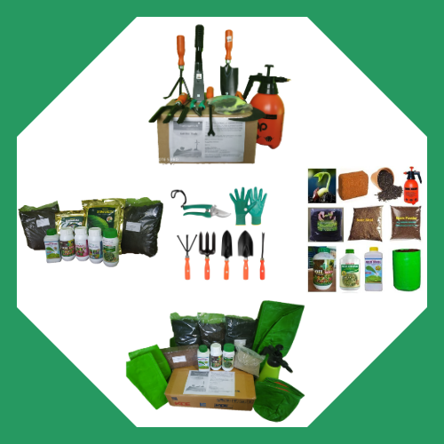 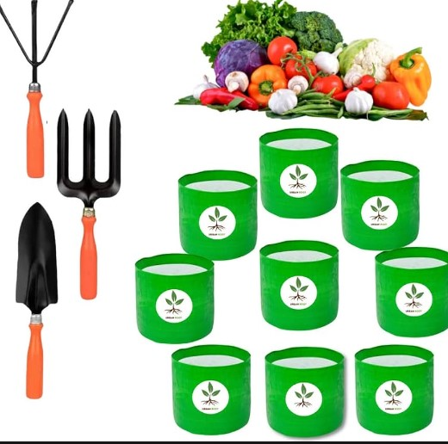

Contact Us:

Email:

[adcf1631@gmail.com](mailto:adcf1631@gmail.com)

Numbers:

9350248712

9872610934

02287455

About Us:

Our core focus is to assist transformation of agriculture or allied activities into agribusiness.

Our Vision :

One-stop solution for farmers & agribusiness enterprises, offering comprehensive services

Our Mission :

Encouraging people to do more of urban terrace farming.

Our Objectives:

* One of the primary objectives is to grow fresh, organic produce in urban areas, contributing to local food production.
* Creating green spaces in urban environments can contribute to the conservation of biodiversity by providing habitats for insects, birds, and other wildlife.
* Organic waste can be composted and used to fertilize rooftop gardens, reducing the amount of waste sent to landfills.

Services We Offer:

 

Purchase Sales

Purchase:

* View Items (Crops available)
* Payment process